Chapter 10, Solution 85.

Using Fig. 10.127, design a problem to help other students to better understand performing AC analysis with PSpice.

Although there are many ways to solve this problem, this is an example based on the same kind of problem asked in the third edition.

Problem

Use PSpice to find V_{o} in the circuit of Fig. 10.127. Let R₁ = 2 Ω, R₂ = 1 Ω, R₃ = 1 Ω, R₄ = 2 Ω, I_{s} = 2∠0˚ A, X_{L} = 1 Ω, and X_{C} = 1 Ω.

Solution

The schematic is shown below. We let rad/s so that L=1H and C=1F.

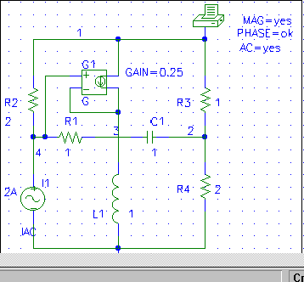

When the circuit is saved and simulated, we obtain from the output file

FREQ VM(1) VP(1)
1.591E-01 2.228E+00 -1.675E+02

From this, we conclude that

V_{o} = 2.228∠–167.5° V.

